An overview of geologic factors influencing hydropower development in Himalayas, India

Dhawan, G.
Executive Director (Geotech) NHPC Limited (A Govt. of India Enterprise), Faridabad 121001, Haryana, India
Raju, M.
Director, Engineering Geology Division IV, Geological Survey of India, 27 J.L. Nehru Road, Kolkatta-760016, West Bengal, India

Received August 2012/Accepted February 2013

Abstract

Abstract should be limited to 200 words and cover the entire paper. Many authors give introduction in a brief manner in place of abstract which is discouraged. Abstract is actually a summary of the entire work carried out. The purpose of giving abstract is to allow researchers and other professional go through a copious bunch of papers to find the relevant work of their own interest. Even though it is said that abstract may stand alone and be able to communicate what the authors want, many writers find it difficult to portray a true picture of their entire work. This is where the judicious choice of approach and use of minimal expressions to convey important messages is required. Figures, tables and pictures are not required in the abstract. It is strongly encouraged to produce original work however preliminary it may be, if it conveys even one single message Journal of Engineering Geology will be happy to publish the same. However, all papers will be professionally or scholarly peer reviewed as the case may be. The journal lays great emphasis on scientific ethics and moral values.

- Introduction:

India is endowed with a rich hydropower potential which is mainly located in northern and northeastern regions of the country. This due to the presence of 2400 km long Himalayas which have a rugged topography and perennial river systems: the Indus, mighty Ganges and Brahmaputra. The Government of is India is actively encouraging the exploitation of this renewable source of energy in an environment friendly manner.

- Geology of the Himalayas:

It is well known that there are four main physiographic divisions in the Himalayas which are also geologically different entities.

- Engineering Geologic Factors Influencing Engineering Structures:

There are many engineering geologic factors influencing the planning, engineering designs and construction methodology.

J of EG, Volume XXII, Nos. 1&2, July 2013

Table 1
Engineering Geologic Evaluation

Sr.  No | Physiographic Division | Main Rock Types | Engineering Evaluation
1. | Siwalik or Sub-Himalaya | Sandstone, siltstone, boulder conglomerate | Low to moderate strength, wide jointing
2. | Lesser Himalaya | Low Grade metamorphics, volcanic, intrusive granite | Wide range in strength but mainly moderate to strong

This example is only a template which is given for formatting, margins, fonts, use of bold and regular, table design, font size for table, manner of writing table headings, therefore please ignore the content. The names of authors are also given for illustration only. The above mentioned style may be strictly followed. Exmples are also given for figures which should be clear and original. Proper references may be given in other cases as required.

- Analysis of Results and Discussion:

Geology plays a vital role in development of hydropower in India because most of the projects are located complex Himalayan geology. Therefore, the role of geology right from the planning stage to commissioning and even afterwards cannot be under estimated. Therefore it is strongly emphasized to increase the input of geology in decision making process. Not only it is important to carry out detailed geological investigations and testing but it is also equally vital to modify the engineering structures based on geologic findings.

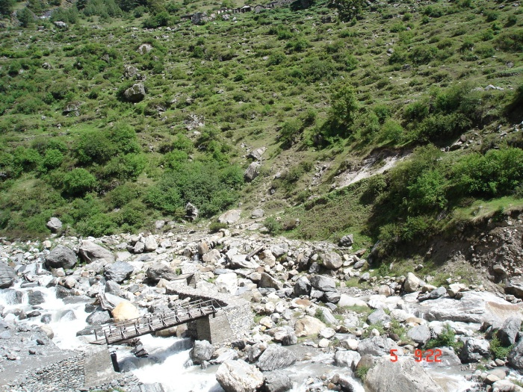
Picture 1 Dhauliganga River

J of EG Volume XXII, Nos. 1&2, July 2013

It may be noted that the pictures should be clear and labeled. The pictures should have been taken by authors themselves or if they are using other work proper references need to be given. Authors will be solely responsible for any copyright violations, if any.

V_{p} = 4.82 km/s & V_{s} = 2.95 km/s
E_{Dynamic} = 55.3 Gpa, G_{Dynamic} 23.1 Gpa, K_{Dynamic} = 31.1 Gpa & σ_{Dynamic} = 0.20
E_{Static} = 30.3 Gpa

- Conclusions:

Hydropower development is very important for proper energy balance in India. Engineering geology accordingly has to be strengthened at all the levels.

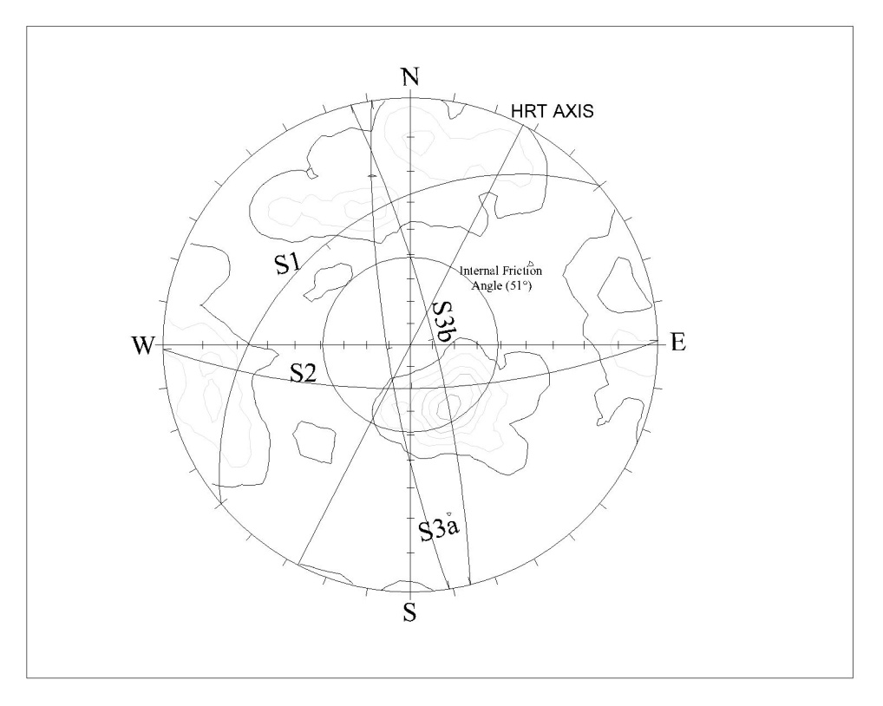
Figure 1 Streo plot, HRT, Section 1b

Just like pictures, figures should also be clear and legible with caption attached to the figure.

J of EG Volume XXII, Nos. 1&2, July 2013

References:

  - Bieniawski, Z.T.(1973). Engineering classification of jointed rock masses. Trans. S.Afr. Inst. Civ.Eng.15, 335-344.
  - Bieniawski, Z.T.(1979). The geomechanics classification rock engineering applications. Proc. 4th Int. Congr. Rock Mech., ISRM, Montreux, 1979, vol.2, 41-48.
  - Bieniawski, Z.T. 1989. Engineering rock mass classification.: Jhon Wiley & Sons. New York, 272 p.
  - Terzaghi, K. (1946). Rock defects and loads on tunnel supports. Rock Tunnelling with Steel Supports. Ed. R.V. Proctor and T. White, Commercial Shearing Co.Younstown, OH, 15-19.*
(* cited from Bieniawski 1989.)

